# GitHub Setup Notes

## New Repo Creation and Connection

1. **Initialize the repo.**

git init

1. **Create a ‘README.md’ file with any comment of your choice for example ‘# qwerty’.** Use any Text Editor of your choice to add long descriptions and formats.

echo "# qwerty" >> README.md

1. **Add the file to git to apply the changes to your online GitHub repo from your local machine**

git add README.md

1. **If you have more than one file in the folder and you want to add every file to git, use:**

git add ..

1. **Add a comment of your choice that serves as a name for your pushed changes.**

git commit -m "first commit"

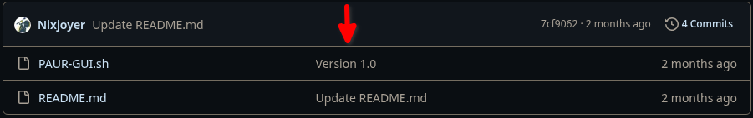

**If you’re doing this for the first time, you may run into this error:**

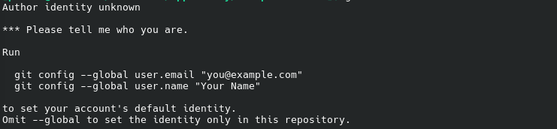

**If so run:**

git config --global user.email [“your@email.com”](mailto:\“your@email.com\”)

git config --global user.name “your name”

1. **If you have several branches in your local repo, preferably change back to your main/master (Depends on what OS you’re using so look at what name is used in the terminal) branch.**

git branch -M main

1. **Connects local repo to GitHub repo through HTTPS/SSH**

git remote add origin [git@github.com:username/repo.git](mailto:git@github.com:MadSharksStudio/qwertyu.git)

1. **Pushes the changes made on your local repo to your GitHub repo via HTTPS/SSH**

git push -u origin main

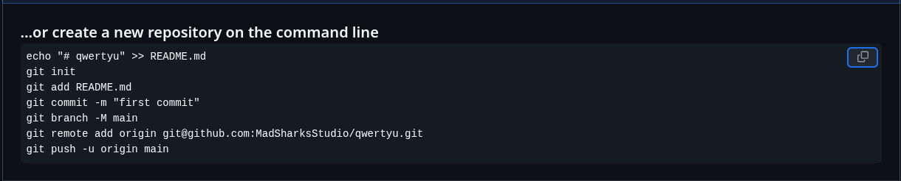

## Existing Repo creation and Connection

**If you already had a local repo you can just connect it to your GitHub repo and push any changes made via these commands.**

git remote add origin <https://github.com/User/repo.git>

git branch -M main

pit push -u origin main

## 

**Note:** All of these of commands are available to you every time you create a new repo in GitHub, however it’s recommended you practise that way you don’t have to come back to these types of notes.

## Appendix

1. **Comment -** text that’s added to serve as notes or explanations.
2. **Branch -** a movable pointer to a specific commit in a repo.
3. **Origin -** default location for pushing or pulling changes to a repo.
4. **Repo (repository) -** project folder that contains the README file and any other files used in your project.

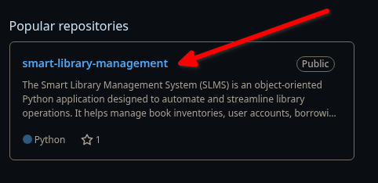

1. **README.md -** markdown file that contains the projects description.

